**Done By : 21k-3881**

**Lab 10**

**Task 1:**

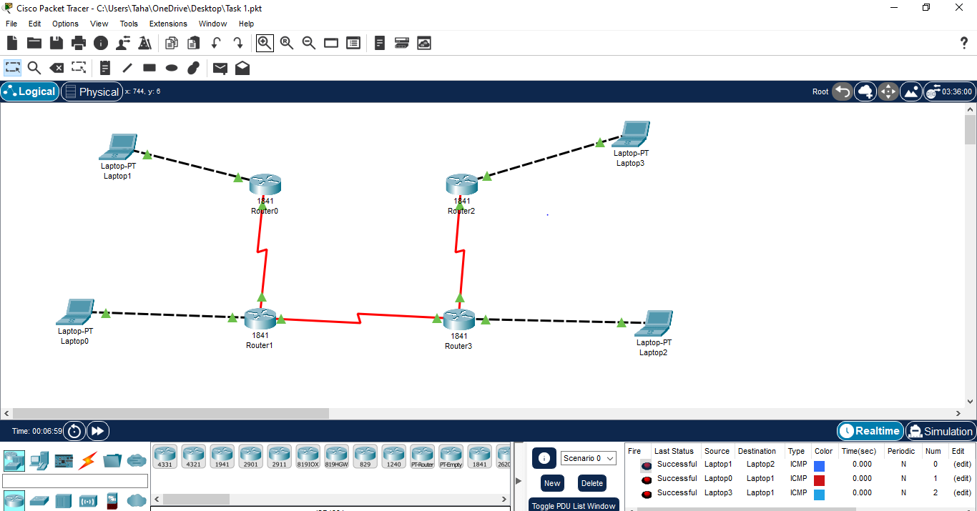

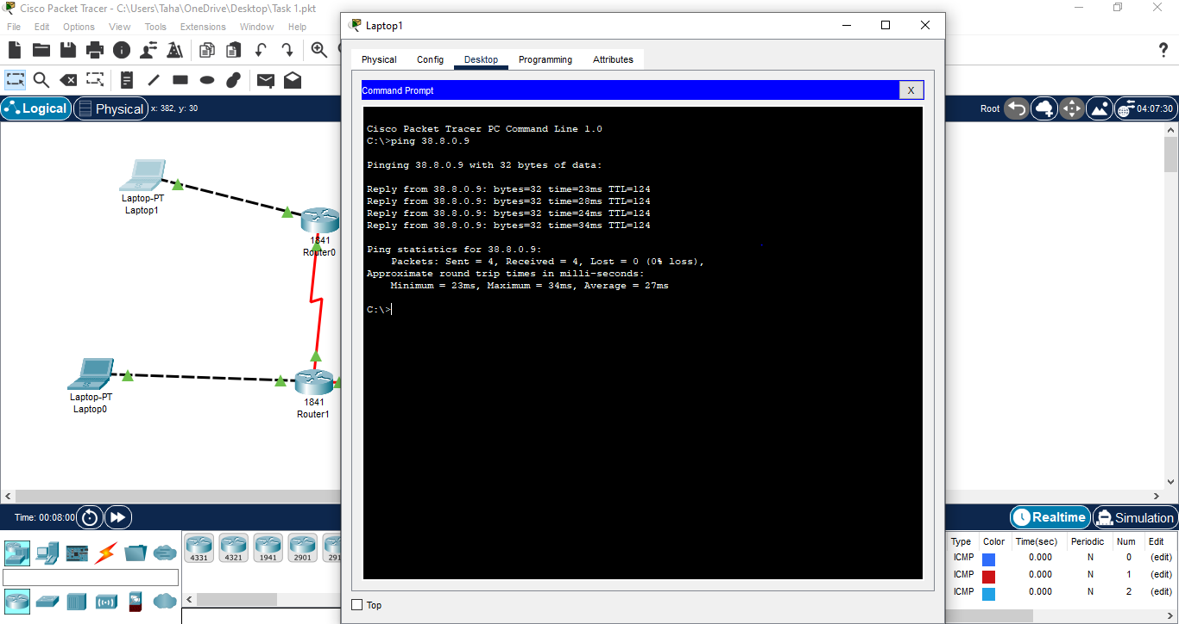

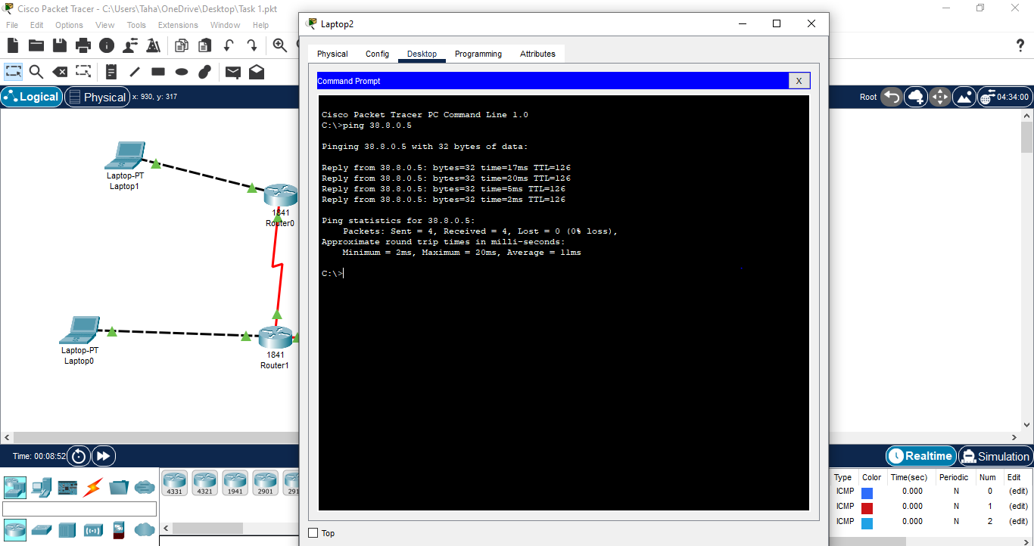

**Task 2:**

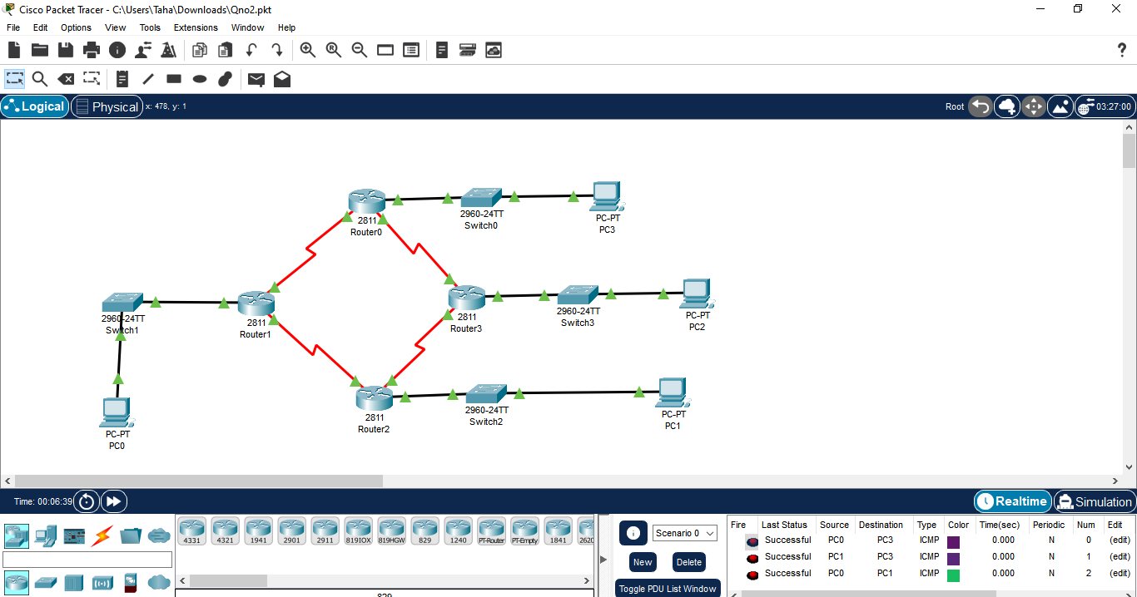

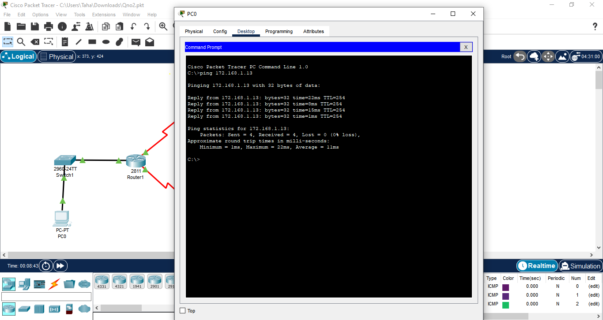

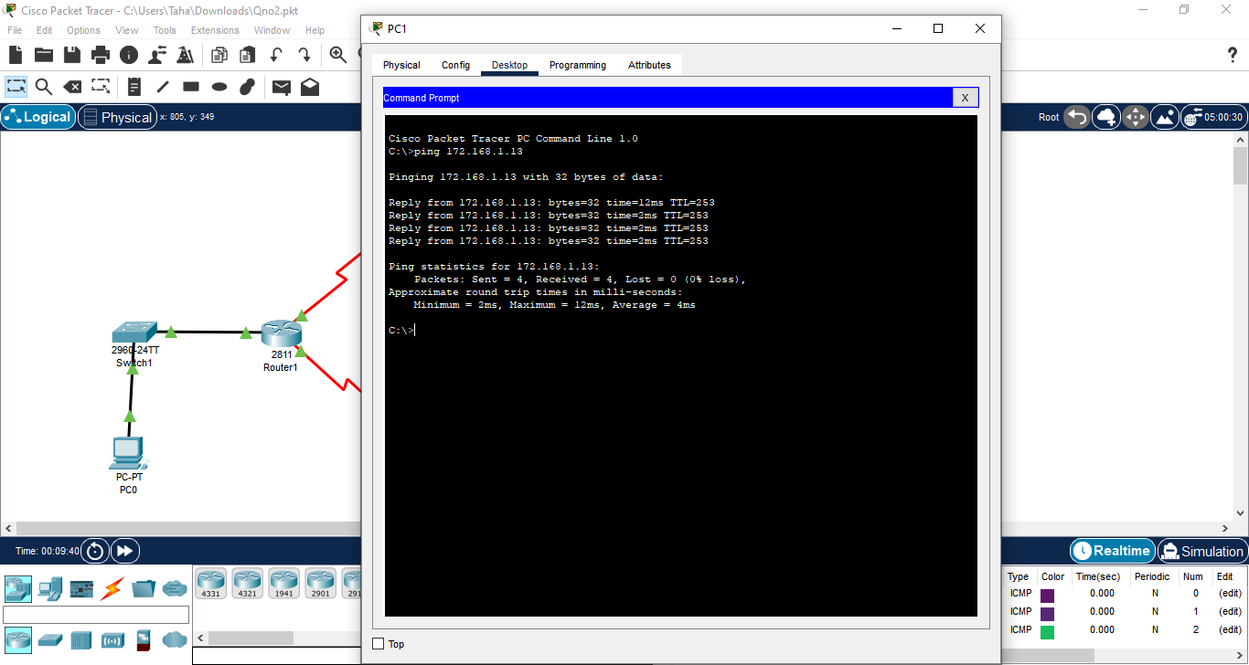

**Task 3:**

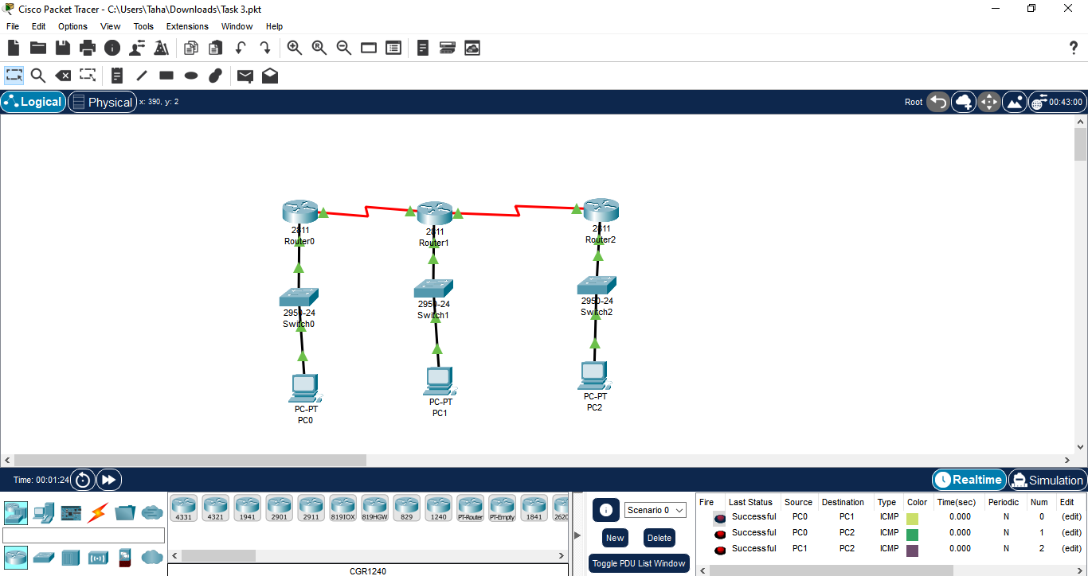

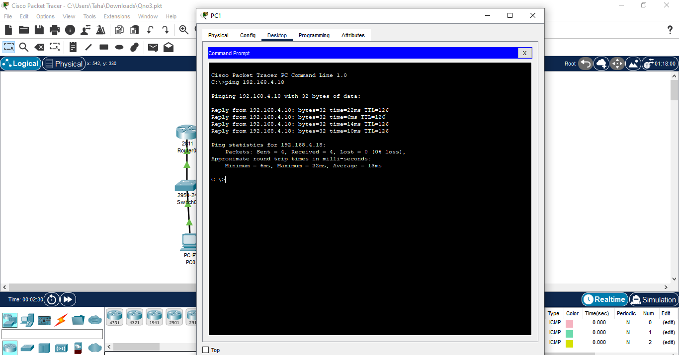

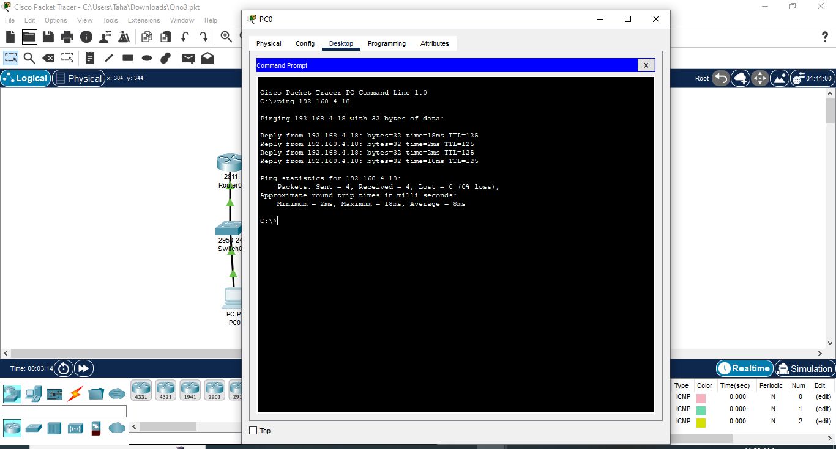

**Task 4:**

**Static Routing:**

Usage: Static routing is employed when the network topology is relatively simple and stable, and the network administrator manually configures the routing table on each router.

Topological Reason: In scenarios where the network topology rarely changes or there are only a few possible routes between network segments, static routing is favored. For instance:

* Small networks with few routers and predictable traffic patterns.
* Point-to-point connections or small branch offices with limited connectivity options.
* Networks with security or performance requirements that necessitate specific routing paths.

**Dynamic Routing:**

Usage: Dynamic routing protocols are utilized when the network topology is complex and dynamic, and routers dynamically exchange routing information to update their routing tables automatically.

Topological Reason: Dynamic routing is advantageous in environments where the network topology changes frequently or where there are multiple possible routes between network segments. For example:

* Large-scale enterprise networks with multiple interconnected routers and switches.
* Networks spanning multiple geographic locations or with redundant links for fault tolerance.
* Cloud-based networks or virtual environments where virtual machines or containers are dynamically provisioned and migrated.